

**INSTITUTE OF INFORMATION TECHNOLOGY**

**JAHANGIRNAGAR UNIVERSITY**

|  |  |
| --- | --- |
| Number of Assignment | : 03 |
| Name of Assignment | **: Search Query from DorkGPT** |
| Course Tittle | **: Cyber Security** |
| Submission Date | **: 25/09/2024** |

**Submitted To Submitted By**

**Moinoddeen Quader Al Arabi**

Ethical Hacker, Forensic Investigator, and VAPT Expert Cyber Security Consultant in Dhaka Division, Bangladesh.

**Md. Shakil Hossain**

ID: 2111258

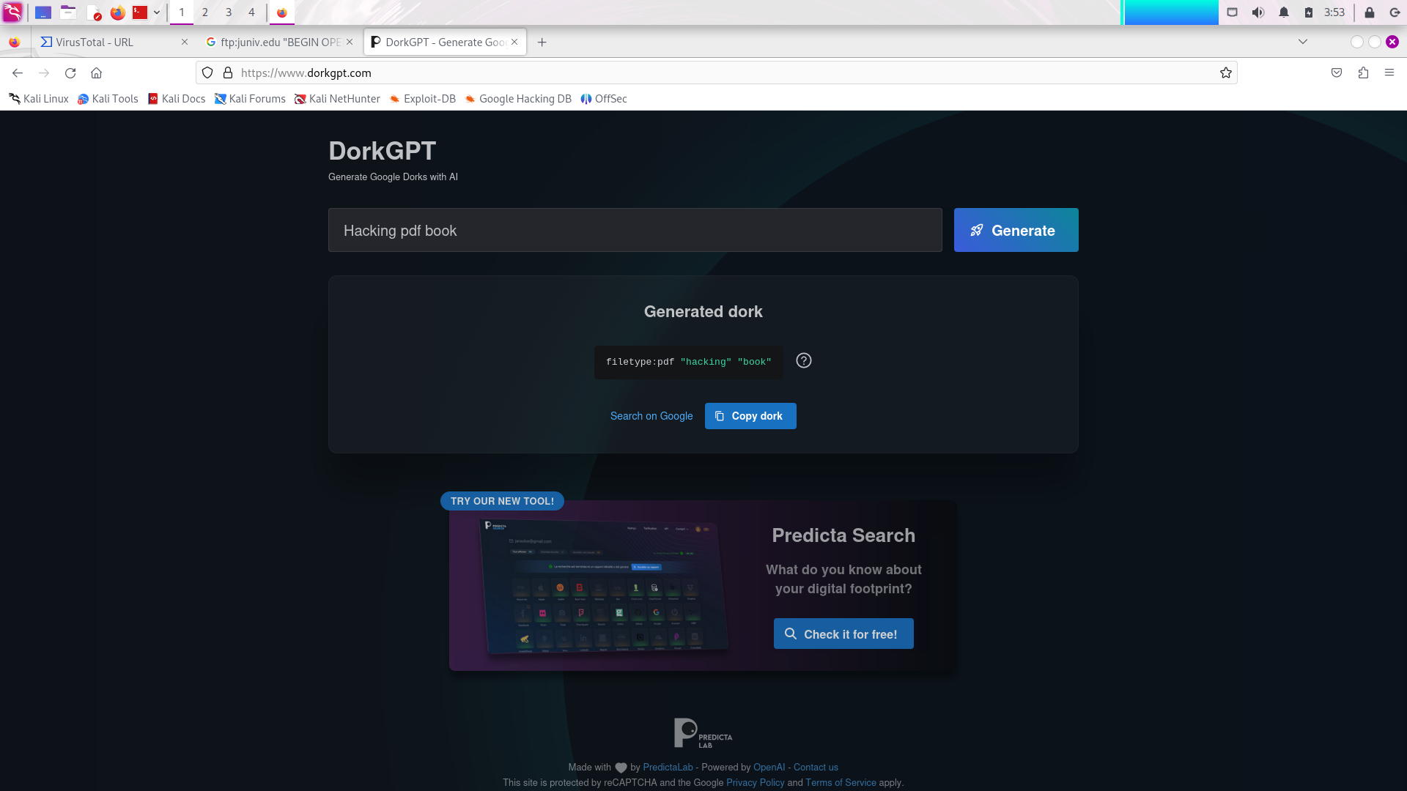



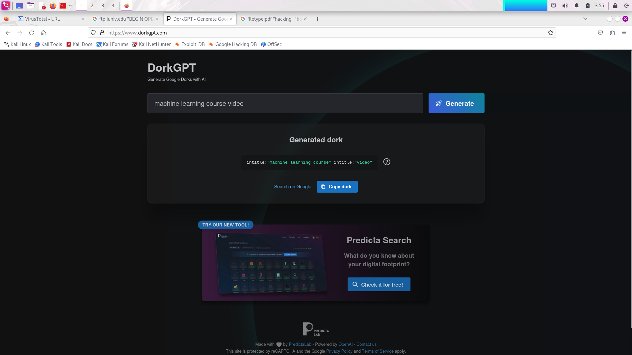



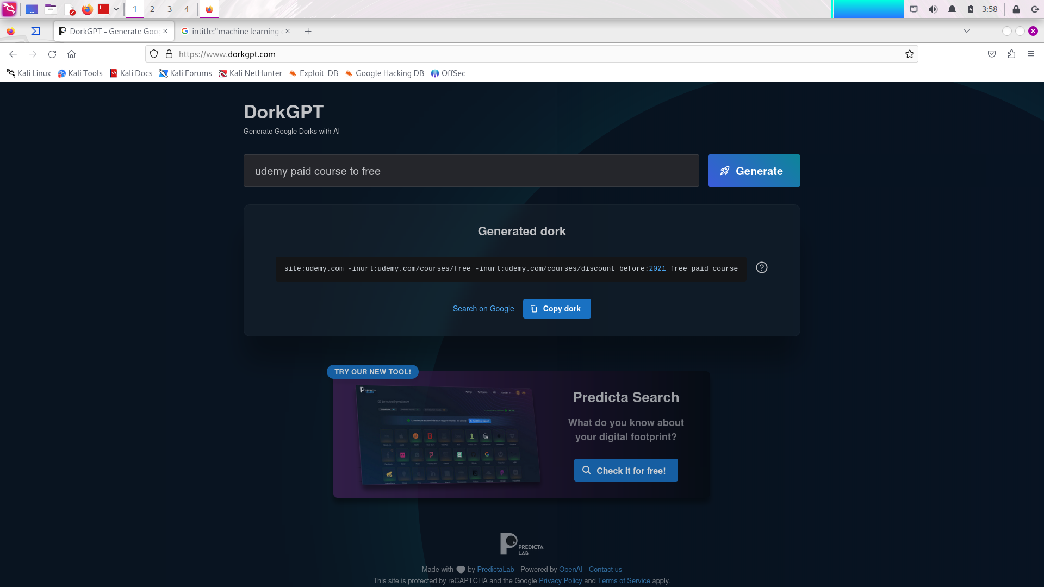

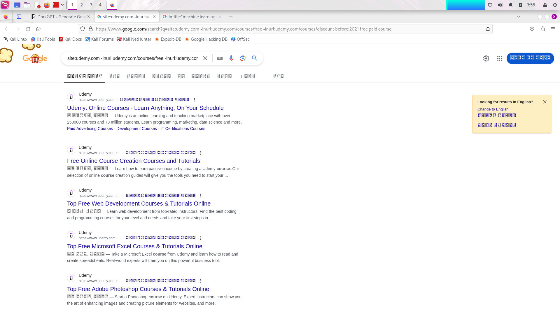

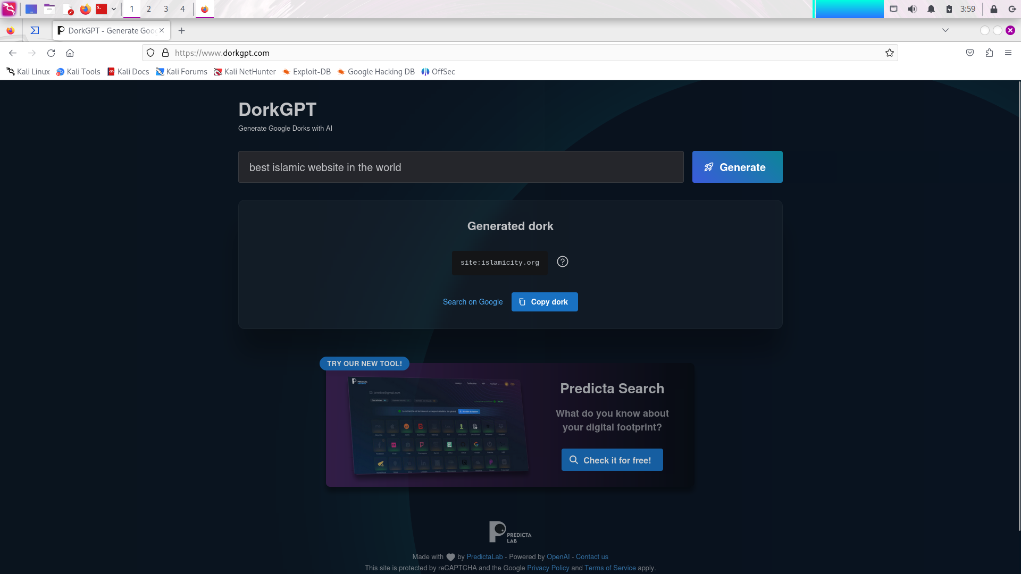



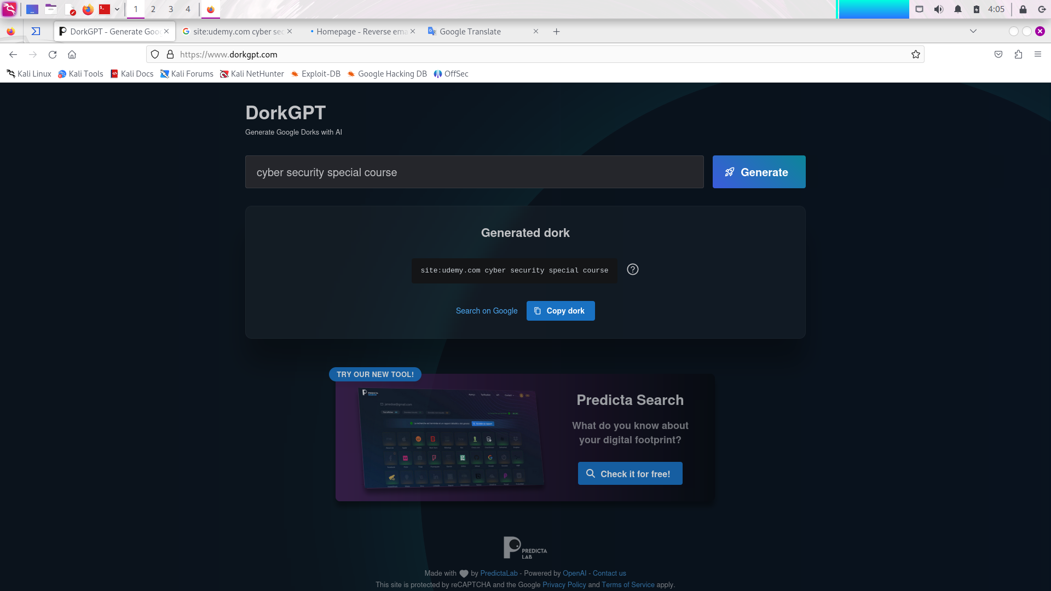

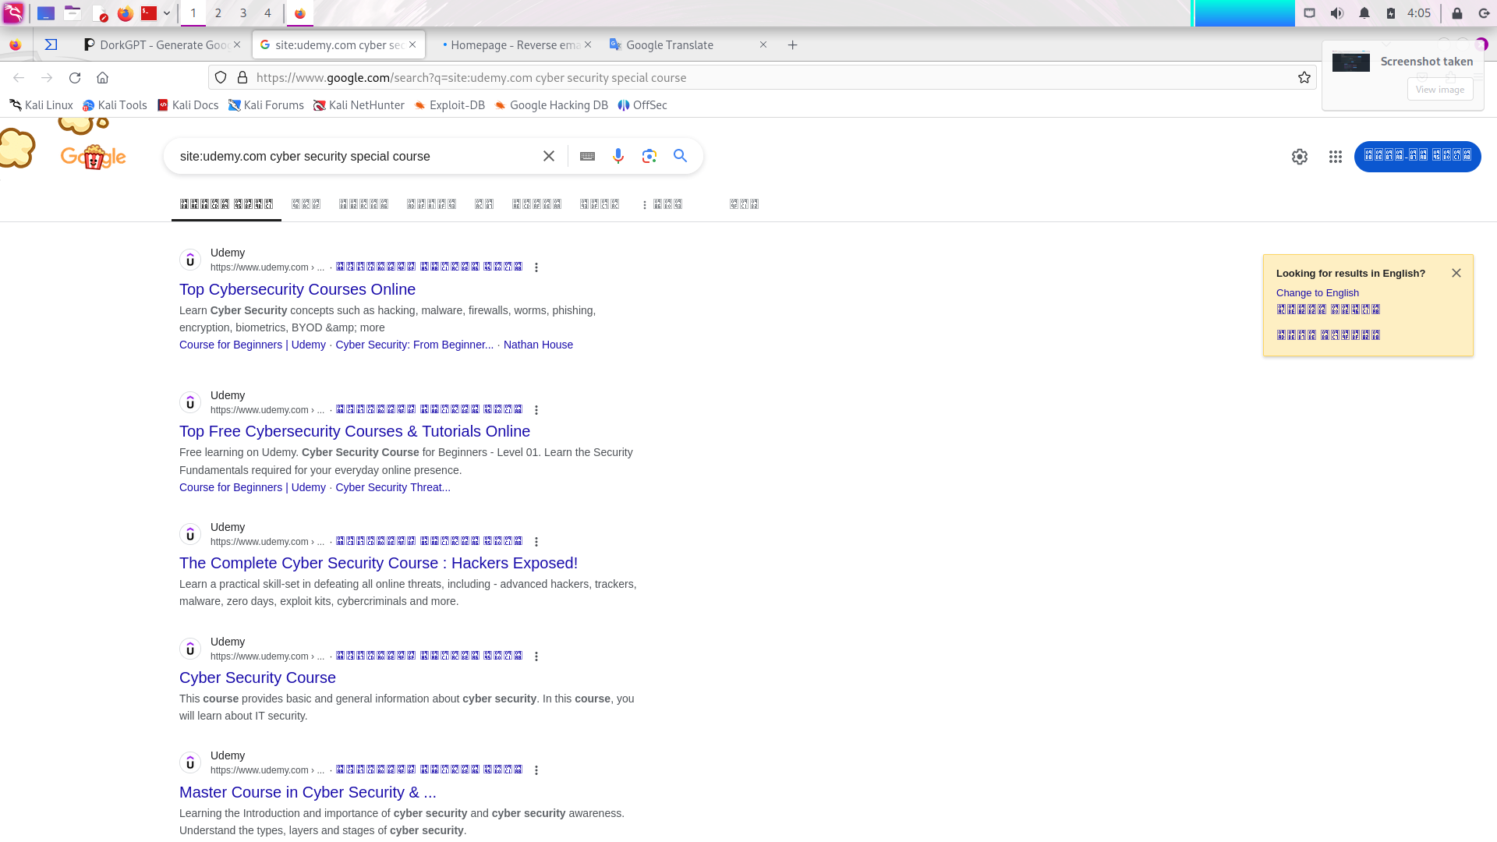

**The End**